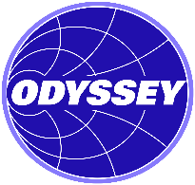
Contact: Larry Broome, Odyssey Technical Solutions
+1.512.989.7007; Larry.Broome@odysseyrf.com

FOR IMMEDIATE RELEASE

Download photo at https://www.odysseyrf.com/partnership-ekksc.png

Odyssey and EKK Eagle Semicon Components Sign Distribution Agreement
Leader in O-ring and Vacuum Sealing Teams Up with the World Leader in Semiconductor Market Repairs

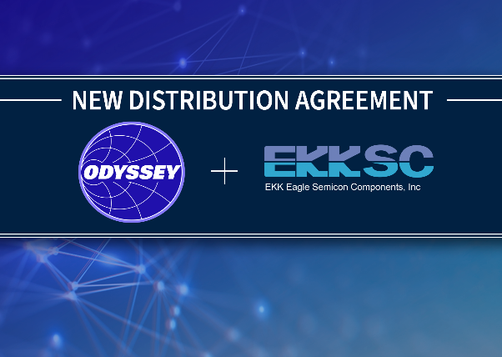
Round Rock, Texas – August 17, 2021 – Odyssey Technical Solutions, world leader in RF, DC, and microwave repairs, is pleased to announce a new distribution agreement with EKK Eagle Semicon Components for both the Americas and European markets. EKK Eagle Semicon Components (EKKSC), a leader in O-ring and vacuum sealing technologies, was established as the sales and engineering division of EKK Eagle for all semiconductor markets outside Japan since 2010, located in San Jose, California.
“In looking for additional products that addressed our existing customers’ needs, EKKSC’s O-rings and related products are an excellent fit,” said Jim Plourde, president of Odyssey Technical Solutions. “Odyssey, with a twenty-year history and over 100,000 successful worldwide repairs, is already working with many of the same people within the wafer fabs and other industries. This agreement offers an excellent opportunity for Odyssey to work with yet another world leader.”
EKKSC became a world leader due to its vertical integration, including manufacturing its own monomers and controlling the entire process from base monomer structure to polymerization. EKKSC’s wide range of Superior® elastomers from FKMs to next generation FFKMs gives it the ability to provide the best solution to the markets it serves. An agreement with EKKSC only further expands Odyssey’s ability to make high-quality repairs with outstanding customer service.
“When we were looking for partners to help support our existing and potential customers, Odyssey Technical Solutions jumped to the forefront. Odyssey is already supporting the semiconductor and industrial markets where EKKSC products are used,” remarked Patrick Giorda, president of EKKSC. “As Odyssey also distributes other critical components, it has an experienced understanding of customers’ needs and expectations within those markets. It is the perfect partner for EKKSC.”
For more information about EKK Eagle Semicon Components, visit www.ekksc.com.
For more information about Odyssey Technical Solutions, call +1.512.989.7007, email sales@odysseyrf.com, or visit our website at www.odysseyrf.com.
About Odyssey Technical Solutions

Odyssey Technical Solutions’ technology center is a state-of-the-art repair facility located in Round Rock, Texas, with additional repair facilities in Singapore and Nijmegen, The Netherlands. The engineering staff consists of highly skilled professionals working in a meticulously maintained facility, specializing in RF Generators, Automatch Networks, DC Power Supplies, and Microwave Generators / Power Supplies. Odyssey’s reputation for quick turnaround times and customer satisfaction has provided it the opportunity to become involved with an array of different processes and equipment within the industry. The Odyssey team is engaged, motivated, customer focused, and current with the latest advancements in process and equipment engineering. Services include repair, refurbishment, core exchanges, process and equipment engineering, and equipment sales. Odyssey is an ISO 9001:2015 and ANSI/ESD S20.20 Certified company, and a US veteran-owned company.
###
For more information please contact:

Larry Broome
Senior Director of Global Sales and Marketing
Odyssey Technical Solutions
Larry.Broome@odysseyrf.com
+1.512.989.7007
Tricia McGough
TW Marketing (agency)
tricia@twmarketing.net
+1.254.383.9700

